

REDUCE FUEL CONSUMTION AND IMPROVE CATCH

Dyneema®, the world’s strongest fiber

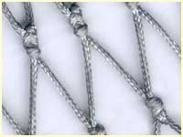

Dyneema netting: improved fishing, larger nets possible at greater speed, lower fuel consumption, easy handling.

Fact:
Out of all the components that make up a trawl the twine contributes up to 60% of the total drag.
With rapidly rising fuel costs Trawler Skippers and vessel operators are forced to look at new ways of reducing fuel consumption or consuming fuel more efficiently.
When towing, there are small changes such as reducing speed which can lower fuel consumption but generally this will result in reduced catch and hence earnings.
To maintain catch levels but reduce fuel costs, the skipper of a trawler can only realistically do one of the following:
- reduce the drag of the trawl gear
- use a more efficient propulsion system
Either of these two things gives the skipper the option of either towing at the same speed and saving fuel or, towing faster and consuming the same amount of fuel but potentially catching more fish.
There are a number of other changes which may have a marginal effect but reducing gear drag is the one which will probably have the most significant effect in the short term.
In calm weather the vast majority of fuel is consumed to overcome the drag of the trawl gear and only a very small proportion to propel the vessel (perhaps 10-20%). This means that gear drag is the main element which needs to be reduced to save fuel.
Bringing down the drag of a trawl can be achieved by reducing its physical size. This in turn decreases parameters such as wingend spread and headline height. It also allows a reduction in the twine surface area of netting. This also has helps ground friction by permitting the use of smaller doors and ground-gear components.
However this choice may not be cost effective as fishing efficiency has been compromised and the exercise may negate any fuel savings that may have been achieved.

Dyneema netting

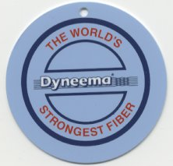

Constructing a trawl with Dyneema is of course more expensive, but as with any other investment it requires some thought. The return time on money spent is spread over a period. One of Crimond’s Dyneema customers renewed his trawl after eight years.
Trials have shown that using Dyneema netting the drag can be reduced by xx% and this coupled by the use of more efficient doors can be increased even more.

Crimond personnel have considerable experience in the development of energy efficient gear and were the recipients of the 2004 Canadian Energy Efficiency Award

Dyneema high performance netting, up to four times stronger than Nylon. Crimond Enterprises sells Dyneema netting with double knots for maximum knot tightness. Crimond Enterprises has introduced trawls made with Dyneema netting into the Canadian market with great success.
Braided Dyneema netting is used successfully in large Pelagic nets and also in Bottom trawls for 300 HP up to 10,000 HP trawlers. With Dyneema netting these trawls all reduced drag greatly and fishing improved.
Dyneema high performance fiber has proved to be an exiting new netting material. Abrasion resistance is better than Nylon. New Dyneema SK 75 has a tensile-strength 4 times that of Nylon! Shock absorption capacity is amazing. Dyneema netting is far less sensitive to sharp surfaces, hence the use in bullet-proof vests.
Dyneema – the world’s strongest fibre
Dyneema opened up completely new possibilities. Fibres made of this synthetic high-tech material are ten times more resistant than equally thick fibres made of steel. Dyneema is used not only for bullet-proof jackets but also for nets and ropes. With a thickness of just 1.1 millimetres Dyneema achieves the same resistance as a three-millimetre thick net rope made of PE. Dyneema nets are thus lighter, smaller trawl doors are possible, engine power can be reduced, less fuel is needed. The new material thus contributes towards greater profitability in the fishing sector

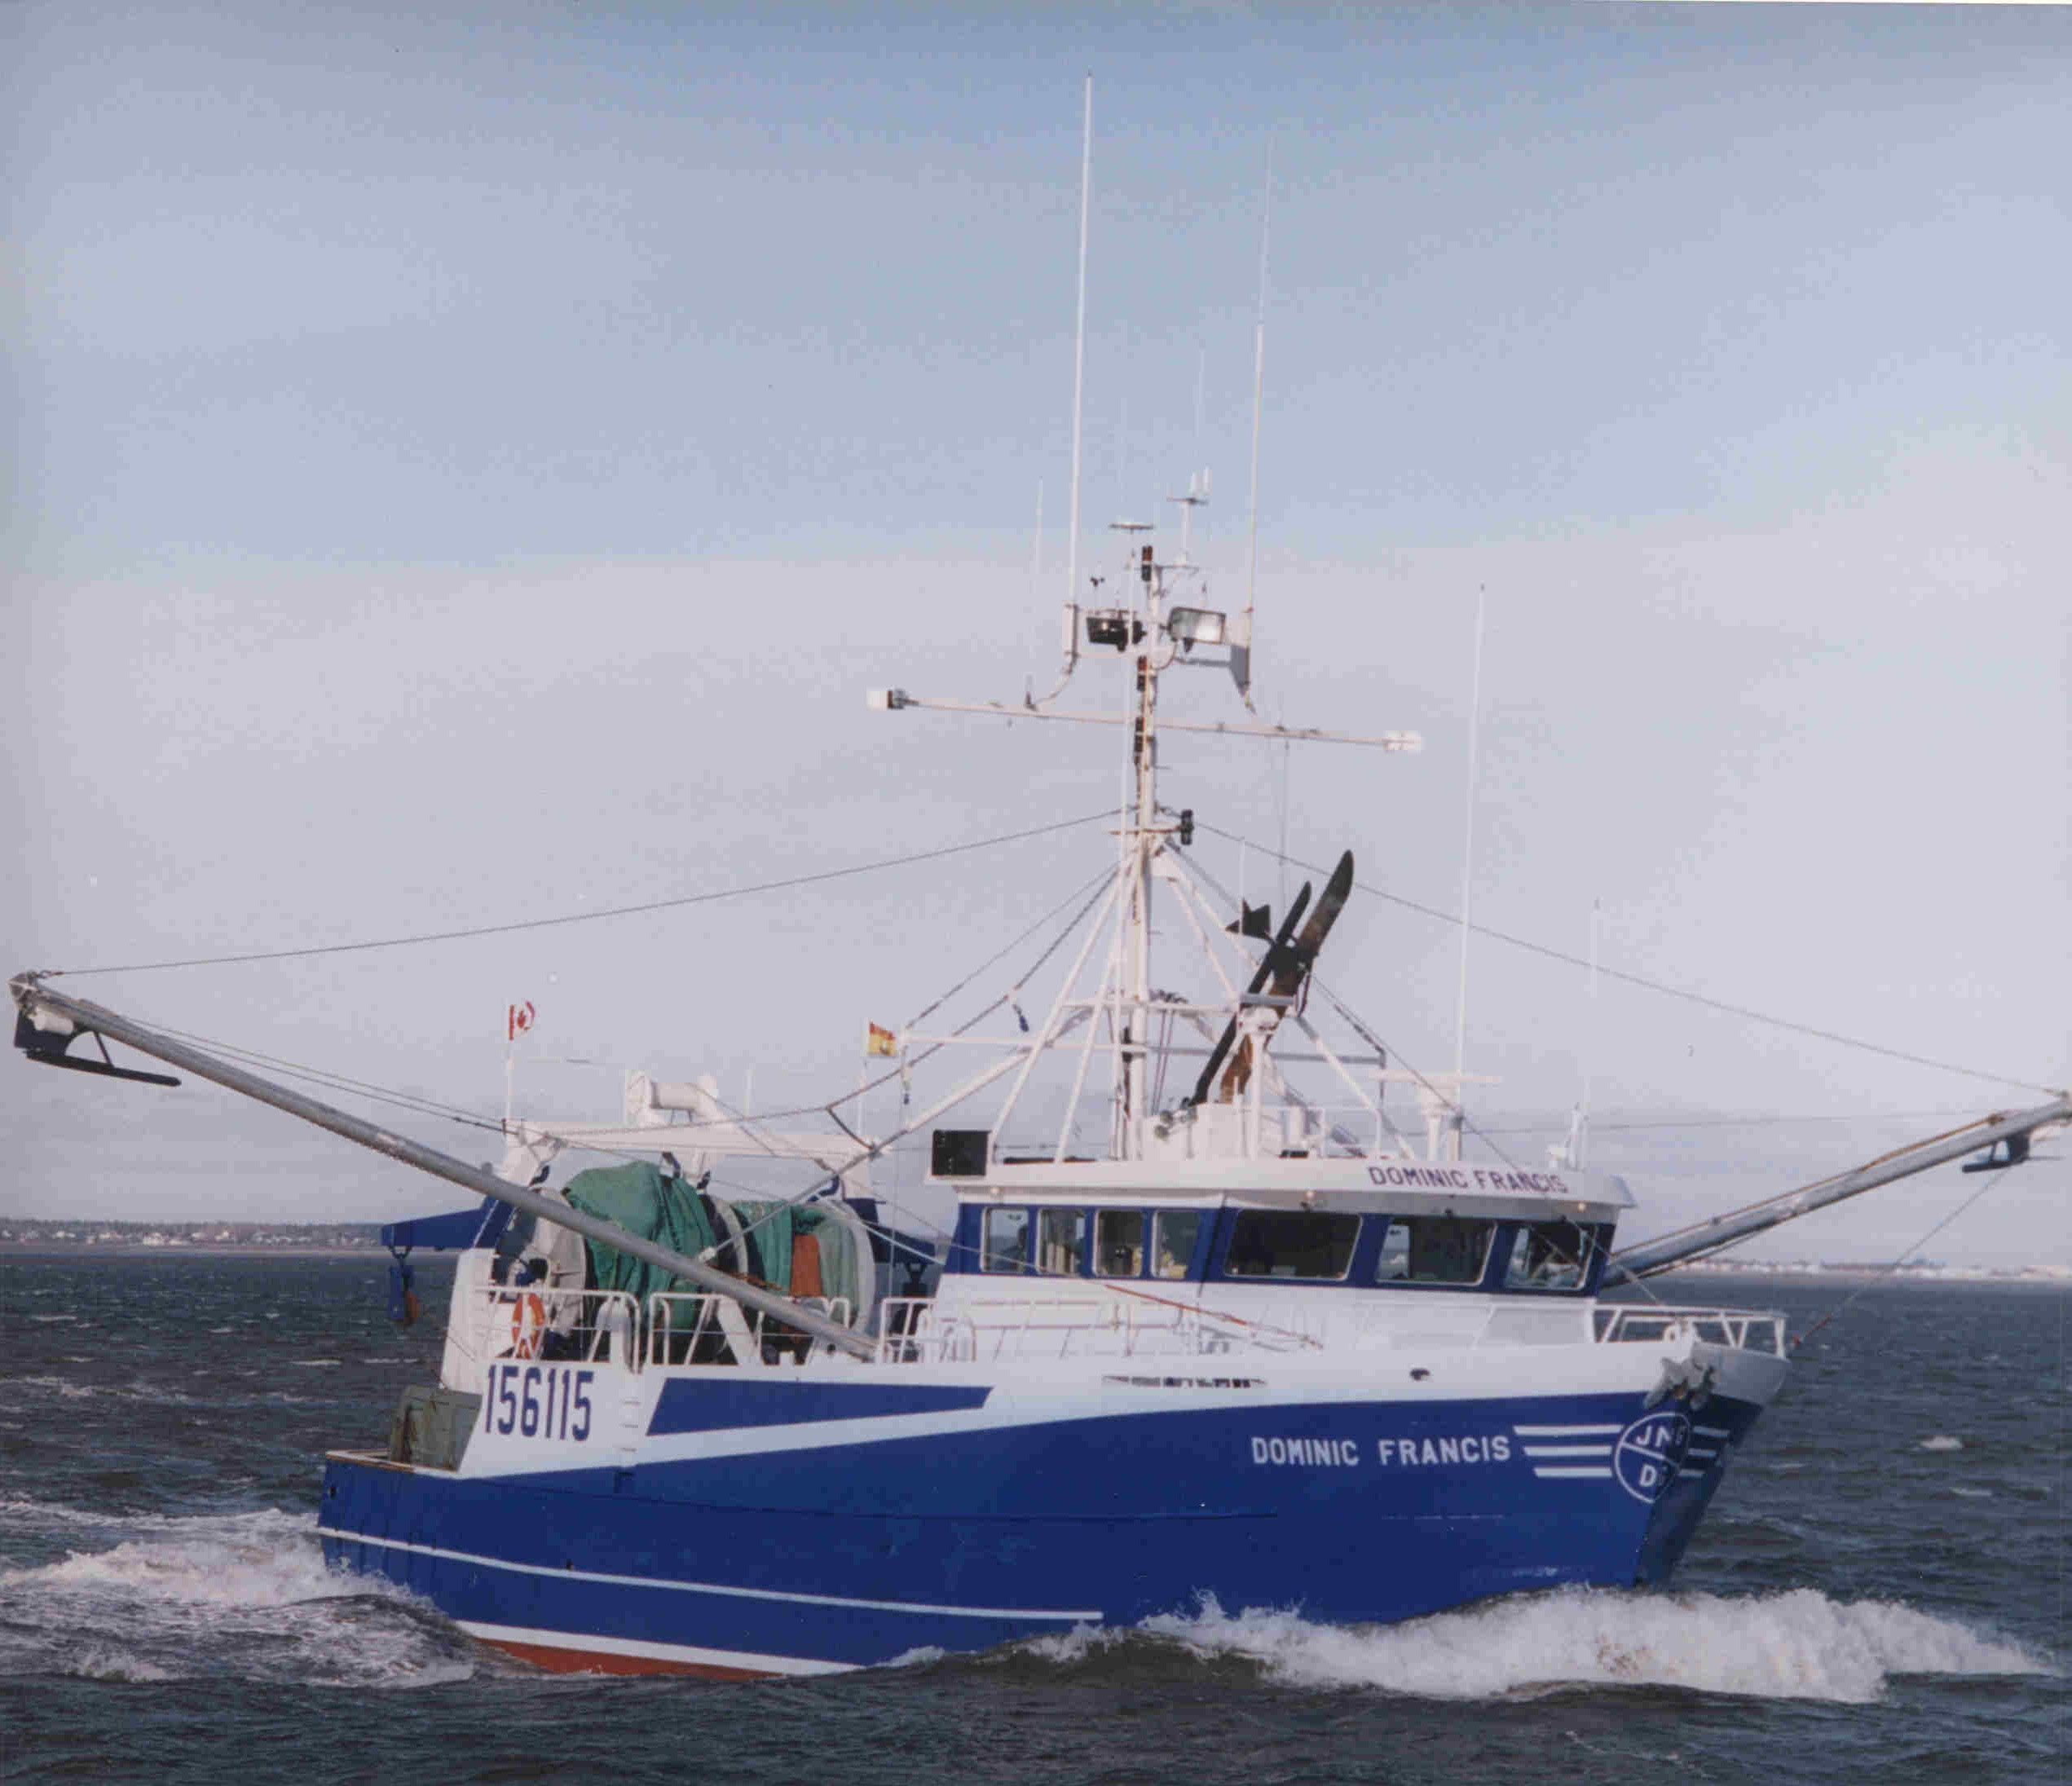

For many years New Brunswick Skippers such as Daniel Gionet owner of the “Dominic Francis” have seen the benefits first hand of trawling with Bison trawl doors and Crimond Enterprises Shrimp trawls constructed from Dyneema netting.

Strength comparison of braided Dyneema and Regular PE Netting

Braided Dyneema Netting
Type | Twine size | Apr. M/Kg | Apr. breaking force Kgs
SK65 | 1.1 mm | 1200 | 160
SK65 | 1.5 mm | 660 | 290
SK60 | 2.0 mm | 400 | 420
SK60 | 2.5 mm | 320 | 570
SK75 | 2.0 mm | 400 | 560
SK75 | 2.5 mm | 320 | 740
SK75 | 3.0 mm | 205 | 1080

Regular Polyethylene netting
Twine size | Appro. M/Kg | Appro. Breaking Force KGs
3.0 mm | 220 | 140
4.0 mm | 140 | 232
5.0 mm | 90 | 310
6.0 mm | 80 | 400

With 50% less diameter, 1.5mm Dyneema netting with a breaking force of 290kg or 639 lbs is 100% stronger than regular the 3mm green PE below.

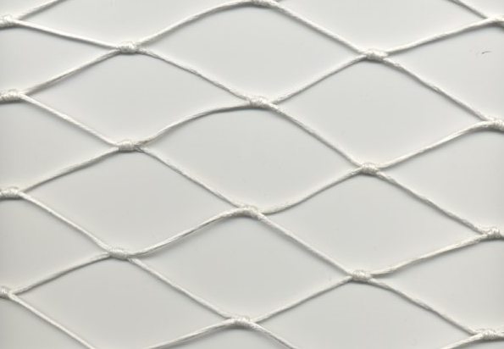

Regular 3mm PE netting with a breaking force of 140kg or 308 lbs

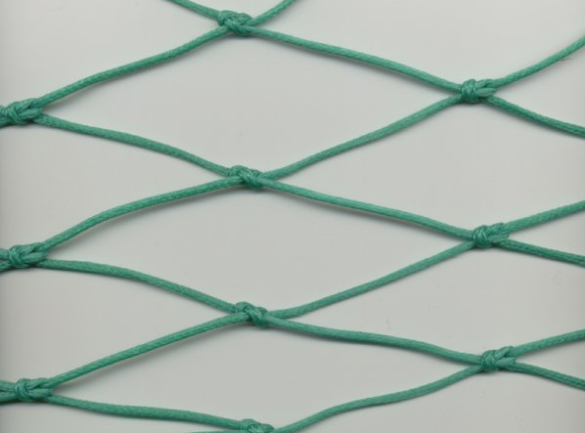
For more information contact:
Crimond Enterprises Limited

Tel (902) 468-1355

